There are three ways we could colorize the interface of ScrY.

1. ΔEz
2. Normalized ΔEz
3. Log propensity

Log propensity seems to make the most sense. Vik agrees. We went through a couple thought experiments. He's a great visual thinker, like Daniel. But I seem to trust him more to pick the right things to visualize, though I should trust Daniel too. But after Vik describes a visualization it's very clarifying.

Consider a colorization by ΔEz.  
Consider a polar residue in the loops.  
Infinitely far away from the protein, ΔEz is zero. Moving it to the loops it gets a little positive, moving it farther towards the membrane center it gets more positive.  
Consider a hydrophobic residue in the loops.  
Inifinitely far away from the protein, ΔEz is zero. Moving it to the loops it gets a little negative, moving it farther towards the membrane center it gets more negative.  
So, polar residues are always positive, and hydrophobic residues always negative.  
Suppose you colored by ΔEz so that positive was red, zero was white, and negative was blue.  
If you saw an arginine next to a leucine in the loops, they would both be white. But inside the membrane, the arginine would be red, and the leucine blue. There would be a gradient of color, with the most color in the middel of the membrane.  
This is *sort of* what you see:  
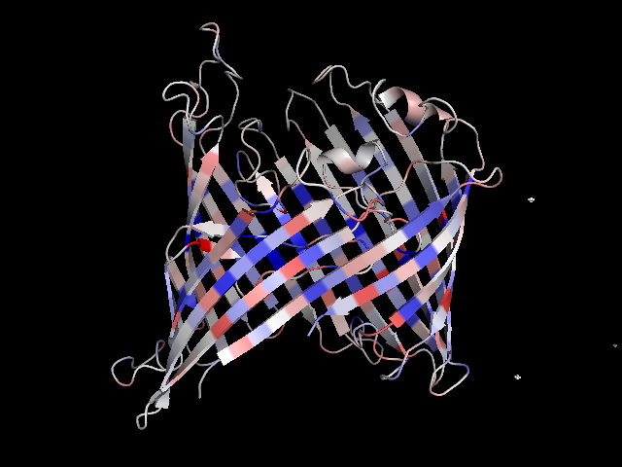

So this I understood in two ways. One was, I made my mind act like it. I simulated ΔEz. Then, I saw what it meant: not an energy, but a change in energy. But it was from the simulation that I saw why it must be positive for some and negative for others. So I saw something inn a sumulation and I came to understand, after seeing it, that the referent of the Δ was why it was always positive or always negative.

So there's that. This could not possibly be what was used in the colorization of the figure from the Ezβ paper in Protein Science.

Daniel says that what we did was (2), normalized ΔEz.  
Basically, you divide by the amplitude. becomes , and becomes .  
Wait...

ΔE0? What's that mean?  
Oh. Energy of transfer from infinite distance to the center of the bilayer.

So, that normalizes to [0, 1]. But it also erases the information about hydrophobic/polar, so some get flipped upside down, that is, you put them through the function 1-x.  
Basically, it's the answer to, "what percentage of its maximum energy does it have in this position?"  
(Threonine would end up with as sharp a transition as everything else, even though since its distribution is basically flat, the z value of this transition would be arbitrary)  
There's some information loss here. Some residues might just me less stable than others.   
But that's not reflected in a propensity either... doesn't propensity normalize to absolute frequency? I think it's connected with what Vik was telling me once about a reference state... whatever that was and whatever that was for... something to do with the math of the boltzmann distribution. You divide the frequency of one state by the frequency of another...